TC-CMS-017
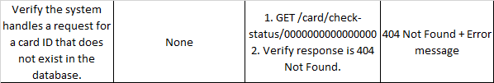
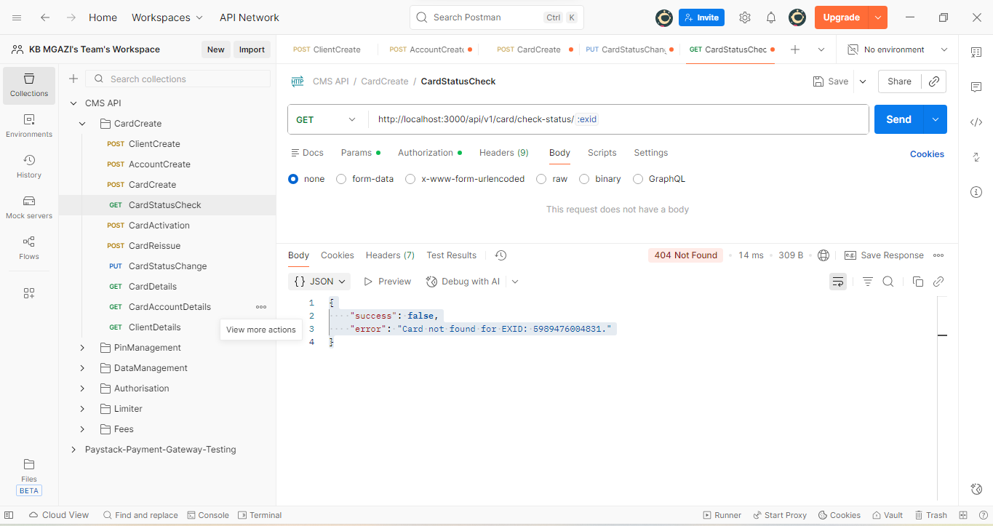
Response:
{
"success": false,
"error": "Card not found for EXID: 5989476004831."
}

